Meeting Report
Meeting | Monday, 19 October 2026, 07:54
Started by | -
Platform | -
Duration | 12.4 min
Participants | Others
Languages | English, Indonesian, Marathi
Overall tone | Frustrated
Your total meetings with Ink | 6
Your total meeting minutes | 18.3 min

Summary
Karthik joined the meeting to find that most team members were not present because the office is closed today and tomorrow for the Pooja holiday. Expressing frustration that no one notified him in advance about the holiday schedule, Karthik decided to terminate the call and instructed Paul to organize a mandatory engineering all-hands meeting for Wednesday at 9:30 AM to address team communication and expectations.

Timeline
- 03:02 Initial Check-in and Greetings - Participants exchange greetings and check on missing attendees in Marathi and English.
- 06:05 Attendance Concerns and Holiday Notice - Karthik raises concerns over missing participants and learns the office is closed for the Pooja holiday.
- 07:18 Adjournment and Next Steps - Karthik closes the meeting and asks Paul to set up a mandatory all-hands engineering meeting for Wednesday at 9:30 AM.

Highlights
- [00:17] Bookmarked
- [00:21] Bookmarked

What was discussed
- Holiday Absence and Communication Lapse: Team members did not attend the scheduled call due to a two-day Pooja holiday; Karthik expressed dissatisfaction that management was not informed beforehand to avoid scheduling conflicts.
- Rescheduling and Mandatory Engineering All-Hands: The call was ended early, and Karthik directed Paul to schedule a compulsory all-hands engineering meeting on Wednesday at 9:30 AM.

Key points
- Bookmarked moment at 00:17 highlights initial check-ins and efforts to message team members.
- Bookmarked moment at 00:21 emphasizes early coordination regarding participant availability.
- Team members were absent due to office holidays today and tomorrow for Pooja.
- Karthik was frustrated that nobody informed him of the office holidays beforehand, leading to wasted time.
- The team agreed to adjourn the call immediately and resume work on Wednesday.
- Paul was instructed to schedule a mandatory engineering all-hands meeting on Wednesday at 9:30 AM.

Decisions
- Adjourn the meeting immediately to observe the two-day Pooja holiday.
- Schedule a mandatory engineering all-hands meeting for Wednesday at 9:30 AM.

Action items
Task | Owner
Set up a compulsory engineering all-hands meeting for Wednesday at 9:30 AM | Paul

Suggested follow-ups
- Hold the compulsory engineering all-hands meeting on Wednesday at 9:30 AM.

Draft follow-up email
Subject: Update: Meeting Adjourned for Pooja Holiday and Wednesday All-Hands
Hi Paul and Team,

Thank you for clarifying today's holiday status. Since the office is observing the Pooja holiday today and tomorrow, we have adjourned today's call.

Moving forward, please ensure that holiday closures and scheduling conflicts are communicated in advance so meetings are not set up unnecessarily.

Next steps and action items:
- Paul: Please organize a compulsory all-hands meeting for the engineering team on Wednesday at 9:30 AM.

We will reconnect then to address team updates and communication.

Best regards,
Karthik

Speaking analysis
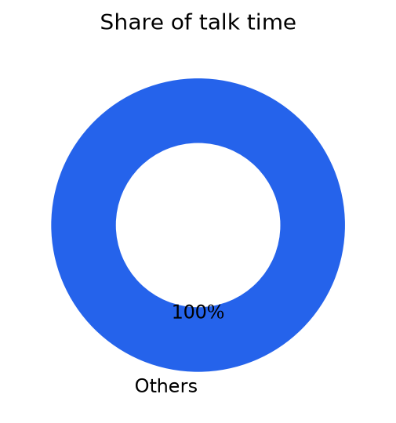
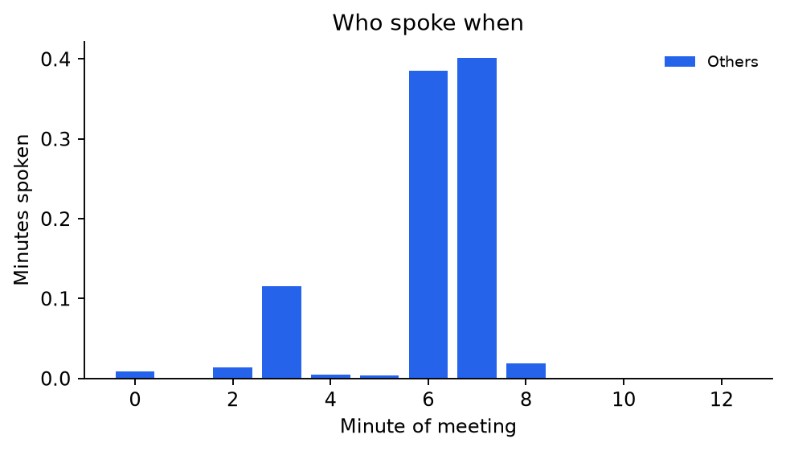
Speaker | Minutes | Share
Others | 1.0 | 100%
Remote speakers are named from the active-speaker highlight on the meeting screen; unknown moments are grouped as 'Others'.

Full transcript
[03:02] Others: Hello. I've been checking on others.
-> Hello. I've been checking on others.
[03:08] Others: यस कार्तिक.
-> Yes, Kartik.
[03:13] Others: All being कस काय तुम्ही?
-> All being How are you?
[03:17] Others: अ मैसेज करून सांगते का त्यांना बरं वाटेल त्यांना.
-> Uh, a message I'll send a message, okay? They'll feel better.
[06:05] Others: Oke, Pak. Saya pikir kita buang-buang waktu.
-> Okay, sir. I think we're wasting precious time.
[06:10] Others: Nah, kita let's stop. Eh enggak, saya enggak mau start. Saya saya enggak happy with this behavior with the team. Oke. So it's a clock is not possible, we should say it's not possible. And that's it. We'll move it to some other time. So uh I have several issues with the team. So let's meet at 9:30 when people show up.
-> Well, let's stop. Uh, no, I don't want to start. I'm not happy with this behavior with the team. Okay. So it's a clock is not possible, we should say it's not possible. And that's it. We'll move it to some other time. So uh I have several issues with the team. So let's meet at 9:30 when people
[06:36] Others: Can you organize? Hello. So let's organize 9:00. Okay?
-> show up. Can you organize? Hello. So let's organize at 9:00. Okay?
[06:43] Others: Uh today is Pooja holiday. Our office today and tomorrow. So that's why somebody should have told me right? Yes. Somebody could have messaged me saying that today is a holiday. We have not working, right?
-> Uh today is It's a Pooja holiday. Our office today and tomorrow. So that's why somebody should have told me, right? Yes. Somebody could have messaged me saying that today is a holiday. We have not working, right?
[07:00] Others: I don't know whether it's a holiday or not holiday. I'm not in the office. And I don't take holidays. I work seven days a week. Okay. So people have to tell me today is a holiday. I would not bother people to come come to join, right?
-> I don't know whether it's a holiday or not a holiday. I'm not in the office. And I don't take holidays. I work seven days a week. Okay. So people have to tell me today is a holiday. I would not bother people to come come to join, right?
[07:18] Others: Anyway, so if it today is a holiday, let's just hang up. So we will only meet on Wednesday. Is that it? Yes, Karthik.
-> Anyway, so if today is a holiday, let's just hang up. So we will only meet on Wednesday. Is that it? Yes, Karthik.
[07:28] Others: So today and tomorrow are holidays. Yes, Karthik. Okay. Perfect.
-> So today and tomorrow are holidays. Yes, Karthik. Okay. Perfect.
[07:34] Others: Thank you for letting me know. Okay. So we'll connect on Wednesday. Okay, Karthik. Okay. Uh Paul, can we organize a 9:30? Uh whenever people show up, 9:30. Uh compulsory all hands meeting for engineering. Okay? Okay, Karthik. So set it up on I need to talk to the team. Thank you.
-> Thank you for letting me know. Okay. So we'll connect on Wednesday. Okay, Karthik. Okay. Uh Paul, can we organize a 9:30? Uh whenever people show up, 9:30. Uh compulsory all hands meeting for engineering. Okay? Okay, Karthik. So set it up on I need to talk to the team.
[07:58] Others: Thank you. Okay. Thank you.
-> Thank you. Thank you. Okay. Thank you.

